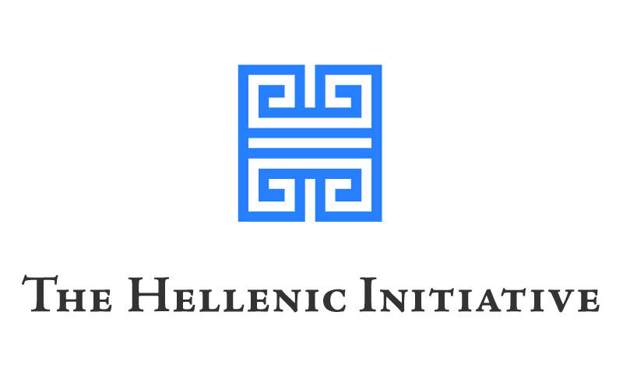
FOR IMMEDIATE RELEASE

THE HELLENIC ENTREPRENEURSHIP AWARD
ANNOUNCES 2015 WINNERS

Three Greek businesses selected from over than 730 applications to share prize funding of €1,000,000.

ATHENS, Greece June 23rd, 2015 – The Hellenic Entrepreneurship Award (HEA) has announced three winners of the 2015 award who, in addition to sharing prize funding of up to €1,000,000, will be provided with an expert mentor and a range of business support services. This year the HEA has again achieved higher levels of participation than in any previous year, with more than 730 submitted business plans. The 2015 winners span a range of commercial ventures from a clean energy technology, to a mobility aid for the sight-impaired, to a specialist online delicatessen.

The Hellenic Entrepreneurship Award was founded in 2012 by the Libra Group on behalf of the Hellenic Initiative (THI), in order to stimulate entrepreneurial spirit by supporting Greece’s most promising new businesses. The winners were chosen on the basis of business plans which demonstrated sustainability, innovation, financial prudence and job creation in Greece. Since its formation, the HEA has presented the award to eleven businesses, supporting their vision and contributing to the implementation of their business plans.

The Hellenic Entrepreneurship Award 2015 winners are:

Heliix – A ground-breaking technology which converts thermal energy into electricity. The company’s first implementation of the technology, Phaethon™, is a device that can be retro-fitted to any type of solar water heater, in order to create a solar co-generation system that produces hot water and electricity at the same time, providing a reduction of up to 30% in a household’s annual electricity costs.
Applicants: Nick Arapkoules, Panagiotis Papadiamantis.

Smart Guide – A wearable electronic mobility guide that senses nearby obstacles and obstructions for the blind and visually impaired. This innovative product will be produced in the facilities of “Lighthouse for the Blind of Greece” by employees who themselves have impaired vision. The project aims to create social as well as economic impact through its workforce focus, affordability and strong export prospects.
Applicants: Karkoulias George, Thravalos Nikos.

Yoleni’s – An online delicatessen that enables European and American customers to purchase authentic products from every corner of Greece fast, easily and securely. www.yolenis.com offers more than 1200 products from 110 highly regarded rural producers across Greece. The website includes a wide variety of food and drink combinations and features a wealth of information on each region plus numerous local recipes and serving ideas.
Applicants: Nikolaos Pipas, Yannis Georgiadis, Petros Agazanis.

Jimmy Athanasopoulos, Chairman of the Hellenic Entrepreneurship Award, stated: “We congratulate not only the winners and finalists, but every entrant who had the courage and resourcefulness to turn their ideas into action through the creation of a business plan. Everyone who enters this award programme shares our belief that Greek ingenuity and business acumen have the power to transform this nation’s economy. We look forward to working with this year's winners to bring these brilliant business concepts to fruition".

For more information about the Hellenic Entrepreneurship Award please visit www.hellenicaward.com
- Ends -

About The Hellenic Entrepreneurship Award:
The Hellenic Entrepreneurship Award was founded in 2012, aiming to support established and budding entrepreneurs by providing funding, support services and mentorship for start-up businesses. The Libra Group has committed over €7 million to the programme which will help entrepreneurs in Greece to generate economic growth in their homeland. The award partners are Piraeus Bank Group which has contributed to the training and education of participants since 2014 through its subsidiary, Excelixi Center of Sustainable Entrepreneurship; the Australian based property investment and development company, Jalouise Pty Ltd., and Mr. Dimitri Goulandris. Amongst the winners’ supporters are Antidote, Kick Athens, Lykourezos Law Offices, Microsoft Hellas, People for Business, Reed Smith, S&Team and SAP Hellas.
www.hellenicaward.com
About The Hellenic Initiative:
Our Mission: Investing in the future of Greece through direct philanthropy and economic revitalization.
We empower people to provide crisis relief, encourage entrepreneurs, and create jobs.
We are The Hellenic Initiative (THI) - a global movement of the Greek Diaspora.
Visit our website: http://www.TheHellenicInitiative.org/
http://onegreece.org
Like us on Facebook: http://www.facebook.com/thehellenicinitiative
Follow us on Twitter: #OneGreece
About The Libra Group:
The Libra Group is an international business group comprising 30 subsidiaries active across six continents. The group has principal operations in shipping, aviation, real estate, hospitality and energy as well as a range of diversified investments. Owned by the Logothetis family, Libra is distinguished by a combination of traditional values, new ideas and an agile mindset that allows it to take advantage of opportunities.
www.libra.com
For further information please contact:
Ms. Christy Sotiriou
V+O Communication, Athens
Office: +30 211 7501213
Mobile: +30 6936640953
Email: csot@vando.gr

